Eshetu Wekjira

Lab 06 - Learning Digital with XOR and Multiplexer

1 November 2022

Task 1: Learning design with Digital by design of XOR

1. Circuit diagram for XOR gates using Inverter (NOT), AND, and OR gates.

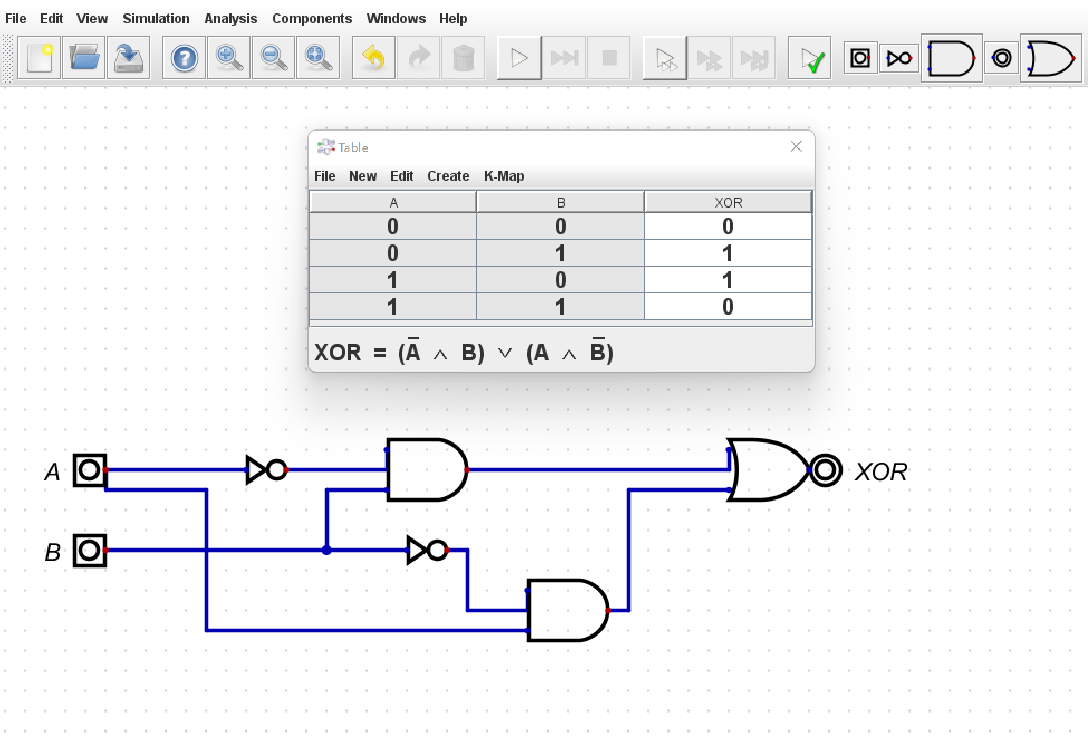

Sum of product for XOR

XOR =A’B +AB’, which gives us the same result as the picture above.

To design the circuit diagram shown above, first, I wrote the truth tables for exclusive-OR, then the only ways when both A and B are one, and the result is zero when we add A’B +AB’.

1. Circuit diagram for XOR gates using only NAND gates.

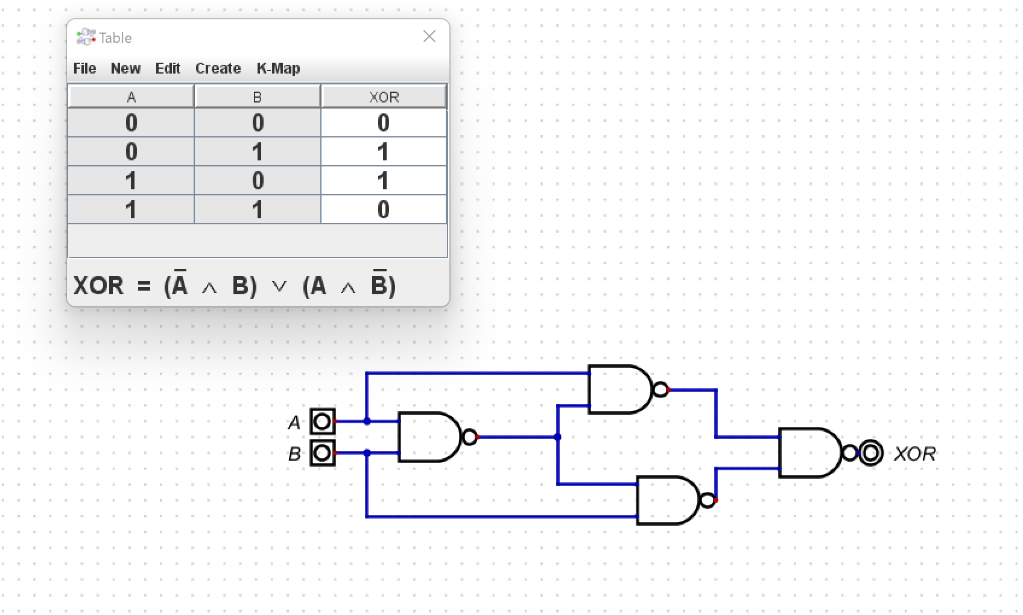

Sum of products of XOR by using only NAND gates.

To get the sum of product and design, first, I wrote the truth tables of XOR; then, I tried to get the same result with the truth tables by only using NAND gates. Finally, I come up with the sum of the product of XOR =((AB)’ A)) ((AB)’ B)

**Task 2: Multiplexer**

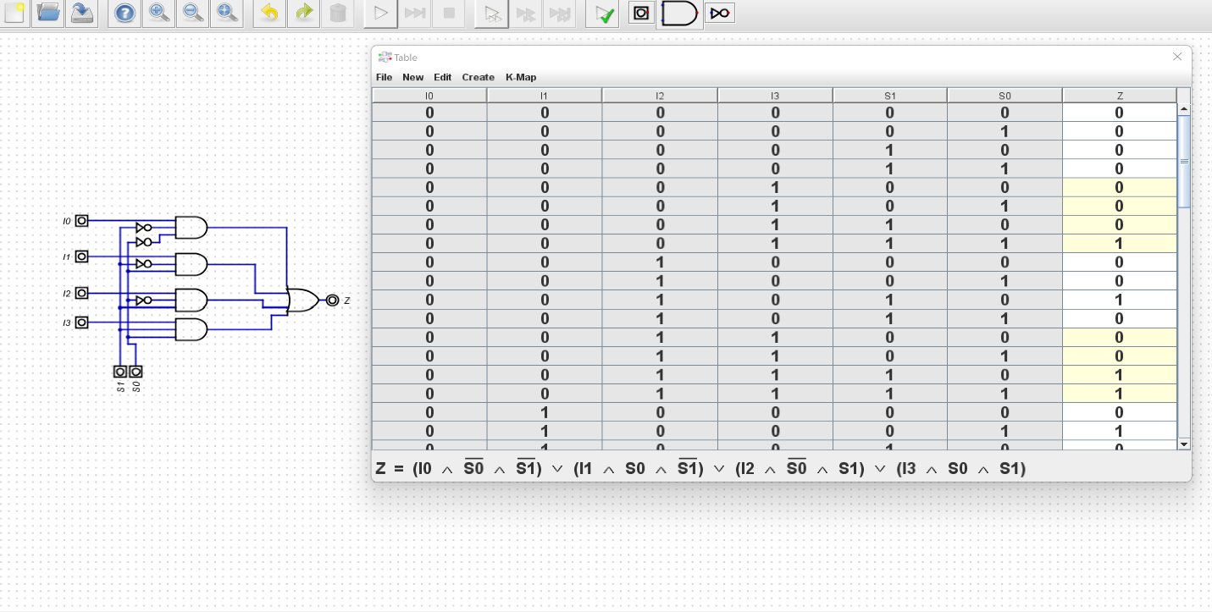

We have four inputs for two select lines in two multiplexers, and multiplexers cannot change the logical level of the information. It only corrects input and output. We must find that all our results should have one value depending on the select lines. Depending on this result, I design the circuit for the multiplexer.